# A

**Seminar Report On**

**“Mobile Jammer”**

**Submitted in partial fulfillment of the requirement for the award of degree of**

**Bachelor of Technology in Computer Applicatiom**

**INTERNAL GUIDE**

**Mrs Vipa Desai**

**SUBMITTED BY**

**Shahveer Suraliwala**

**S.S AGRAWAL COLLEGE OF COMMERCE AND MANAGEMENT**

**NAVSARI**

**Index**

|  |  |  |
| --- | --- | --- |
| **Sr no** | **Subject** | **Page no** |
| **1** | **Acknowledgement** | **3** |
| **2** | **Preface** | **4** |
| **3** | **Contents** | **5** |
| **4** | **What is mobile Jammer** | **6** |
| **5** | **History 8** | **7** |
| **6** | **Basic Principal** | ***9*** |
| **7** | **Types of Mobile jammer** | **10** |
| **8** | **Mobile Car Jamming**  **11** | **14** |
| **9** | **Application** | **15** |
| **10** | **Advantages** | **16** |
| **11** | **Conclusion** | **17** |
| **12** | **Refrence** | **18** |

**Acknowledgement**

**I would like to thank respected Mrs Vipa Desai for giving me such a wonderful opportunity to expand my knowledge for my own branch and giving me guidelines to present a seminar report. It helped me a lot to realize of what we study for.**

**Secondly, I would like to thank my parents who patiently helped me as i went through my work and helped to modify and eliminate some of the irrelevant or un-necessary stuffs.**

**Thirdly, I would like to thank my friends who helped me to make my work more organized and well-stacked till the end.**

**Next, I would thank Microsoft for developing such a wonderful tool like MS Word. It helped my work a lot to remain error-free.**

**Last but clearly not the least, I would thank The Almighty for giving me strength to complete my report on time.**

**Preface**

**I have made this report file on the topic Mobile Jammer; I have tried my best to elucidate all the relevant detail to the topic to be included in the report. While in the beginning I have tried to give a general view about this topic.**

**My efforts and wholehearted co-corporation of each and everyone has ended on a successful note. I express my sincere gratitude to Mrs Vipa Desai.who assisting me throughout the preparation of this topic. I thank him for providing me the reinforcement, confidence and most importantly the track for the topic whenever I needed it.**

**CONTENTS**

* **What is Mobile Jammer?**
* **History**
* **Basic Principle**
* **Types of mobile Jamming**
* **Mobile Jamming Requirements**
* **Components of GSM Mobile Jammer**
* **Applications**
* **Advantages**
* **Conclusion**
  1. **What is Mobile Jammer?**

A cell phone jammer is a device that blocks transmission or reception of [signal](https://searchnetworking.techtarget.com/definition/signal)s, usually by creating some form of interference at the same frequency ranges that cell phones use. As a result, a cell phone user will either lose the signal or experience a significant loss of signal quality.

Cell phone jammers have both benign and malicious uses. Police and the military often use them to limit or disrupt communications during hostage situations, bomb threats or when military action is underway. Portable personal jammers are available to enable their owners to stop others in their immediate vicinity (up to 60-80 feet away) from using cell phones.

Similar equipment is manufactured to block signals in environments where [cell phone](https://searchmobilecomputing.techtarget.com/definition/cellular-telephone) activity may not be desirable, such as theaters, churches and operating rooms.

Cell phone jammers can not legally be sold or used within the United States.

**History**

**After the first cell phones appeared, mobile phone scramblers began to be developed very quickly. Even the most progressive citizens who follow the novelties of electronics do not always know about all the possibilities of these devices. Modern mobile devices are used not only in everyday life, but also not for peaceful purposes. Industrial espionage, blackmail - not all fraudulent activities, it is just a small part of the actions in which cellular phones are involved. In the 21st century mankind was faced with the problem of excessive "flooding" of mobile devices. Owners of concerts and conference halls, theaters, etc. are forced to use the phone jammers in those places where it is required to achieve complete silence.**

**It will be informative to know some information about the fact of history of mobile jammer. An interesting assumption exists, that the ruling king of Jordan significantly influenced on the creation of mobile blockers. He became one of the first people who decided to ask the major developers to try to invent a**[**mobile signal breaker**](http://www.alljammers.com/jammers-shop/cell-phone-jammers.html)**. The thing is that the king Hussein was constantly interfered by annoying mobile calls and long talks of his wards, which were heard even during the prayers in the palace. As a result, he ordered a major US corporation to develop a blocker for cell phones that could block the signal. An obligatory condition was that the radius of the device should cover the full area of the palace.**

**The next one was the Buckingham Palace, which acquired telephone call blocker devices for the serenity of the queen and to block unwanted calls. After all, all the courtiers were progressive people and used the cell phone every day to solve a large quantity of business issues and personal problems. By the way in the United Kingdom, according to a public poll, more than 60% of citizens agreed that the usage of mobile jammers is a forced measure that will promote for comfortable rest in public, cultural and entertainment places.**

**Unlike the United Kingdom, residents of the USA and Western Europe use much more mobile phones. According to the EU information, in France, Italy and Germany, a mobile phone is used by four people out of five. Children skillfully manage with mobile phones as well. Specifically conducted surveys among the French showed that more than 80% of citizens fully support the usage of the**[**telephone call blocker devices**](http://www.alljammers.com/jammers-shop/cell-phone-jammers/usa-16-bands-antennas-gsm-gps-l1-5-3g-4g-wifi-lojack-gps-l1-5-vhf-uhf-remote-controls-jammer-up-to-50m-42w.html)**in most public places where silence is required. Many of them even admit that they can not independently limit the number of personal calls, so global measures will help them in this. Mobile phone jammers can block the latest models of phone signals.**

**Thus, the cordless phone jammers were invented absolutely with peaceful intentions, and only later they were used for mercenary purposes. Such devices are important in protecting the information of specific organizations, especially those whose unique activity directly depends on intellectual property. The mobile phone jammer is an instrument used to prevent mobile phones usage and to block unwanted calls. Different devices owns various characteristics, high power, large or short range cell phone jammer. When used, the blocker effectively disables cellular phones. These devices can be used actually in any location, but are found primarily in places where a phone call would be particularly destroying because silence is expected.**

**Basic principal**

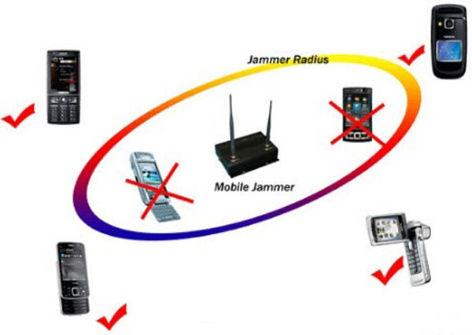

Working of **Mobile Jammer**. The **Mobile** phone**jammer** devices transmit the similar radio frequency which is greater power than the **cell phone**. The communication between the **cell phone** and the**base** station of the phone tower is called as a denial of service attack.

**Types of mobile Jamming**

**Type A:-**

**Pocket Size Jammer**

**As long as this device can be used anywhere you want, your privacy rights will be protected at all times. Wherever you are, no A-GPS tracker or common GPS tracking device will be able to find your location, and no GSM cell phone will violate calm around you. This product guarantees your personal wireless protection from all frequencies it works with in up to 5 meters of space around you. Besides, it looks like an ordinary cell phone and fits even small pockets thus you can use it without any thinkings.**

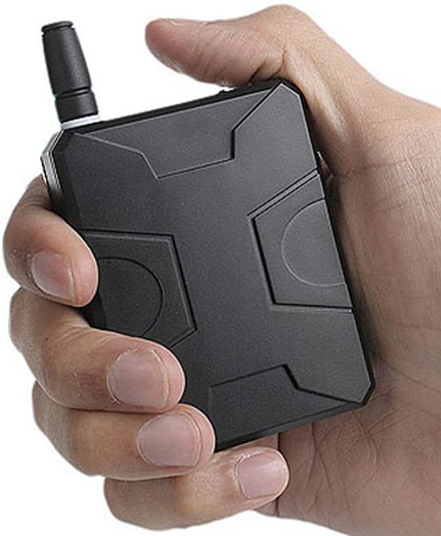

* **TYPE B:-MILITRY BASE JAMMER**

**The TSJ-85W-Vehicle based**[**military jammer**](https://www.thesignaljammer.com/categories/IED-and-VIP-Protection/)**that is capable of protection for smaller convoys, and well suited for VIP protection.**

**It is capable of blocking cellular signals at up to 150 meters to prevent remote IED detonation.**

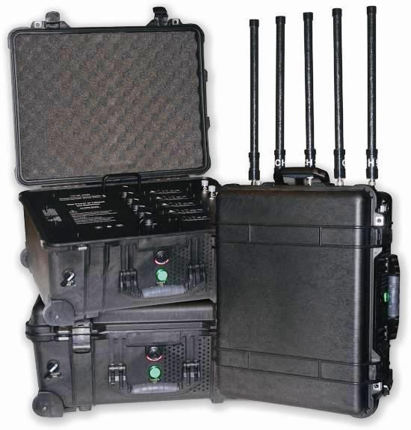

**Type C :-**

**VERY HEIGH POWER JAMMER**

* **The all-in-one solution for blocking GSM, 3G, 4G cellular networks and all kinds of popular cellular standards (GPS, WiFi, Bluetooth, VHF, UHF etc.).**
* **The jammer is using state-of-art technology for maximum performance and to successfully cut-off all cellular communication between mobile phones and cellular cells.**
* **All cellular mobile in vicinity of our very high power multi band jammer will be totally BLOCKED.**
* **The jammer can block signals in six different frequencies at the same time or separately.**
* **The jammer is suitable for VIP Vehicle Convoy Protection.**

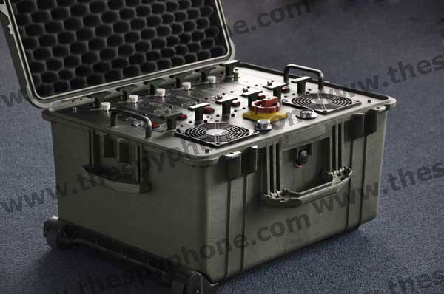

**TYPE D:-**

**4 FREQUENCY BAND JAMMER**

* **This 3G/4G All Frequency Cellular Phone Jammer has 5 Powerful Antennae (4G LTE + 4G Wimax) that can block almost all kinds of 3G/4G frequencies.**
* **Besides jamming both the 4G LTE and 4G Wimax signals the simultaneously, this device also has the ability to block CDMA, GSM, 3G, DCS signals as well.**

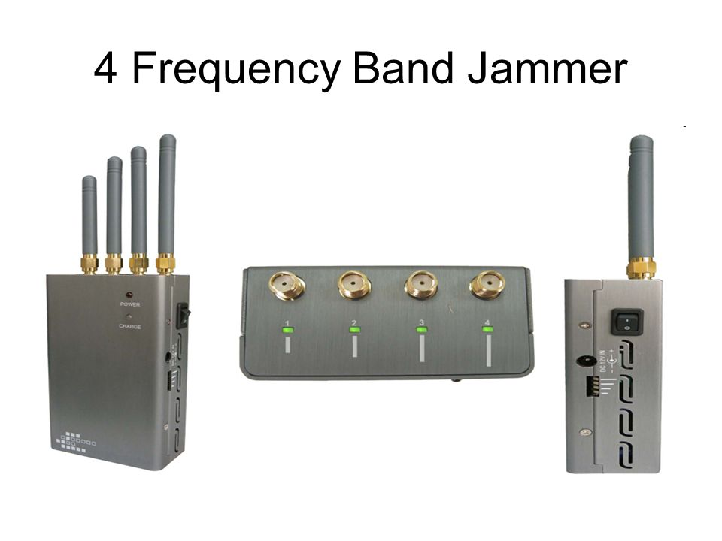

**MOBILE CAR JAMMING**

* **Vehicle jammer system or bomb signal jammer is used to jam radio signal .**
* **It would mount roof of the vehicle and work to counter IED threats .**

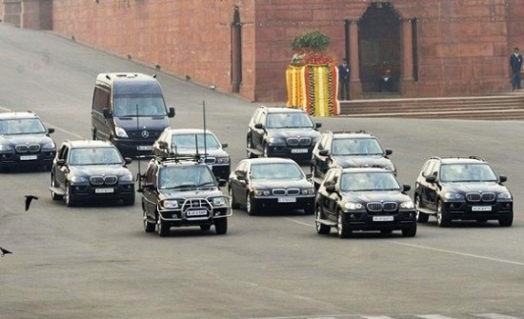Applications

Applications

1. **Stop students from cheating in exams**
2. **Maintain peace in schools and colleges**
3. **Conduct disturbance free presentations**
4. **Create no mobile zone in Hospitals**
5. **Stop terrorist activities by disturbing their communications**
6. **Stop people from disturbing people in public place like temples, churches, restaurants and cinema halls etc.**

**7.The possible application areas of jamming system are:**

**8.Prevent industrial espionage where mobile units are used as buggingdevices.**

**9.Counter terrorism threats such as remotely detonated bombs in high risk areas.**

**10.Eliminate public nuisance in places like movie theaters, restaurants and temples.**

**ADVANTAGES**

1. **MOBILE PHONE SIGNAL JAMMER IN MUMBAI, 9717226478**
2. **Mobile Phone Signal Jammer is the device used to block the signals of cell phones where mobiles are prevented. Basically dell phones are prohibited in a region for the sake of security, to maintain silence and for some other protocol reasons. These jammers prevent the signals of cell phones in a limited range. The Mobile Phone Signal Jammer uses high frequency and low power interference technology that makes it highly proficient. Spy India deals with such security spy devices at an affordable rate. It helps in reducing crime from our society through these security devices. Mobile Phone Signal Jammer**
3. **Most Powerful Mobile Signal Jammer**
4. **Temperature: -10℃ to +50℃⎫ Built-in battery time : 90minutes ⎫ Nextel TACS, NMT, GSM, DCS, CDMA, W-CDMA, PDC, TDMA, PHS, IDEN, AMPS, GPS, UMTS, 3G ⎫ Gross Weight: 0.775Kg System: ⎫ Net Weight: 0.275Kg ⎫ Package Size: 209*52*86mm ⎫ Device Size: 113*60*31mm ⎫ Total output Power: 2 watt ⎫ Built-in Battery: 1800mA/h ⎫ Power supply: AC110-240V 12V ⎫Fabulous Features Of Mobile Phone Signal Jammer**
5. **Enjoy the beauty of silence and stop unnecessary usage of cell phones by using Mobile Phone Signal Jammer**
6. **Mobile Phone Jammer Metal Body Choose Your Mobile Jammer:¬ Painting Signal Jammer ¬ Mobile Signal Jammer High Power 4G ¬ Portable Mobile Jammer ¬ High Power Mobile Phone Jammer ¬ Cellular Phone Jammer ¬ Pocket Phone Jammer ¬ Wireless Camera Phone Jammer Antenna ¬**
7. **Amazing Pocket Mobile Phone Jammer For Various Purposes**

**CONCLUSION**

* **WE can Say every device is act as good aspect as well as bad aspect.**
* **Operating or even owning a cell phone jammer is Illegal in most of the Countries.**
* **Jamming is seen as Property Theft, Safety Hazard.**
* **In many place cell phone jammer is useful but at many place it is a problem.**
* **But its Overall Performance is very good and Helpful in our life.**

**REFERENCES**

1. **https://en.wikipedia.org/wiki/Mobile_phone_jammer**
2. **https://www.slideshare.net/ARYANKUMAR57/project-report-on-signal-jammer**
3. **https://www.ukessays.com/essays/information-technology/technical-report-on-cell-phone-jammers-information-technology-essay.php**
4. **https://www.electroschematics.com/1003/mobile-cell-phone-jammer/**
5. **https://www.wikihow.com/Make-Your-Own-Cell-Phone-Jammer**
6. **http://blog.jammer-store.com/2011/06/how-to-make-your-cell-phone-jammer-diy-guide/**
7. **https://www.quora.com/How-do-I-build-a-cell-phone-jammer**